Los Angeles International Airport (LAX) is one of the busiest airports in the United States with 74,937,004 yearly passengers in 2015. It has four, runways oriented at 24-6. Two are arrival runways and two are departure runways. The network of taxiways can support most aircraft. For heavier aircraft, such as the Airbus A380, only certain taxiways may be utilized due to safety concerns. This can add to the taxi traffic. LAX’s terminal layout is a multi-unit pier-finger concept for its 121 gates. While some terminals are connected past the security checkpoint, others are isolated units. The multi-unit terminal concept allows individual airlines to take part in financing terminal upgrades to their needs. The tightly spaced pier-fingers also create traffic in the gate area. Careful coordination of planes is necessary when taxing to or from gates.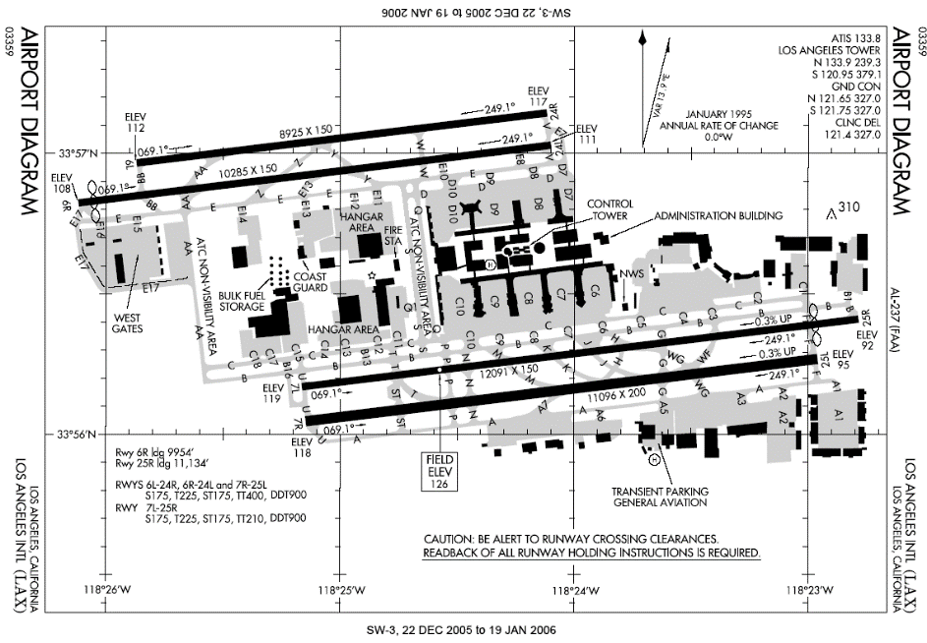

The Burbank Bob Hope Airport (BUR) serves as a regional airport for northern LA County. It processed 3,943,629 passengers in 2015. It has two runway oriented at 15-33 and 8-26 which are 5,800’ and 6,800’ respectively. This restricts the type of aircraft that can operate out of BUR. It has a total of 14 gates in a linear and curve-linear arrangement. Per the FAA safety standards, the current terminal is too close to the existing runways and a new terminal will be built to replace the current one in the future.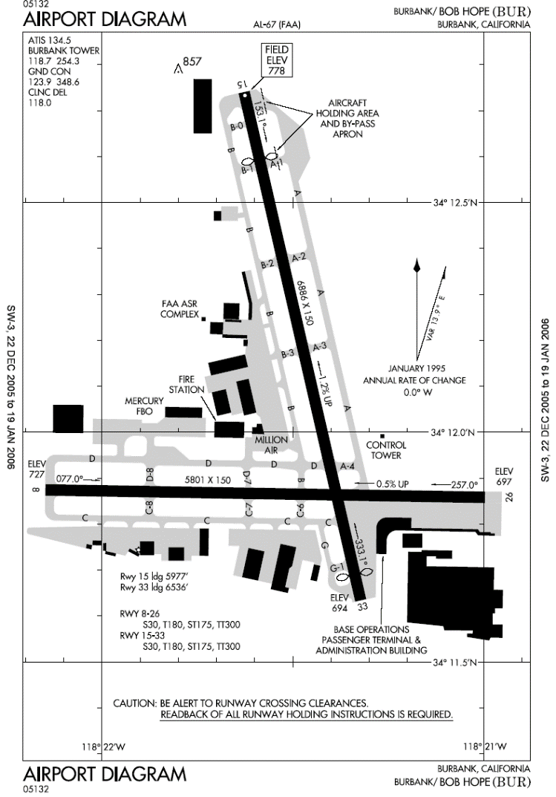

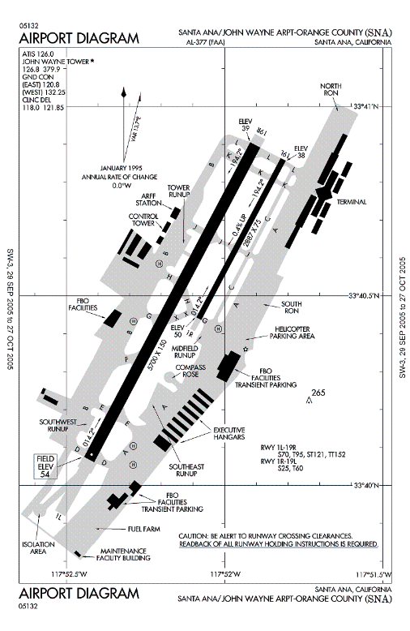

The Santa Ana/ John Wayne airport (SNA) serves the Orange County area as a regional airport. It handled 10,180,258 passengers in 2015 and is equipped with one large runway oriented 19-1. There are 26 gates at SNA all contained within the same building. The terminal layout style is linear which allows for an easy flow of airplane traffic around the gate area. SNA also operates on strict noise abatement restrictions.

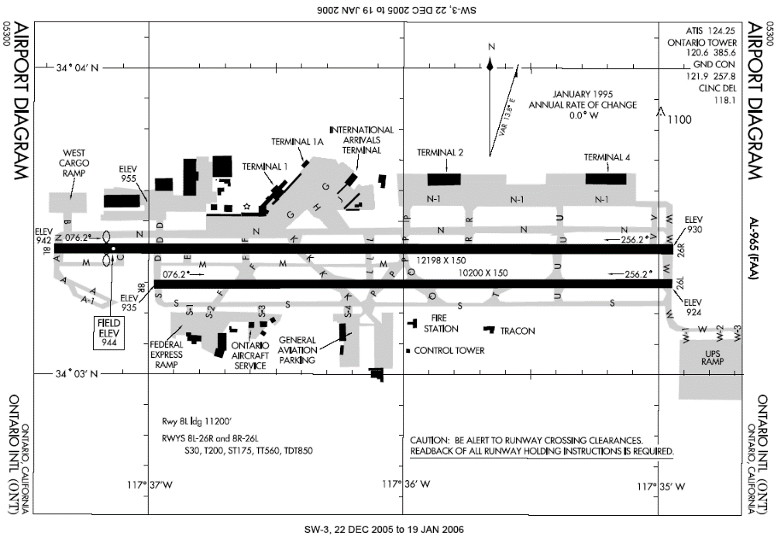Ontario International Airport (ONT) is the eastern most airport in the LA Basin and the most removed from the other 4 airports. Annually, it serves 4,209,311passengers from its 26 gates. The terminal buildings are multiple units and linear which creates a lot of room for airplane traffic while taxing. ONT’s two runways are both over 10,000’. The airport is the primary air shipping hub for UPS in Southern California because of these runways and the low passenger volume. ONT was a member of Los Angeles World Airports (LAWA) from 1985 until November 1, 2016 when it was returned to the city of Ontario. This membership is speculated to have has some effect on the amount of passenger traffic ONT normally receives. 

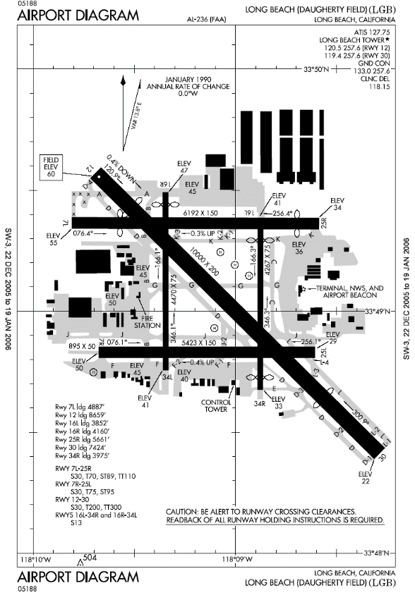 Long Beach Airport (LGB) is a regional airport for the city of Long Beach. It served 2,523,686 in 2015 out of 11 gates. The terminal layout is a single linear building where passengers board their planes via stair tower on the tarmac. There are 5 runways at the airport. Two short north-south runways, two medium length east west runways and a 10,000’ runway oriented 12-30. This allows for a wide variety in the aircraft fleet servicing LGB but creates a more complex system of taxiways. Similar to SNA, noise abatement policies are strictly enforced at LGB.

Data Sources and Initial Analysis

To conduct the study, the Aviation System Performance Metrics (ASPM) database was used. This database provides a wealth of information on individual flights arriving or departing from a chosen airport. The data utilized in this study included the carrier; scheduled gate, taxi and flight times; actual gate, taxi and flight times; and any delay. After hearing the project proposal and meeting with the team. Professor Rakas allowed us to use the database for the study. One member was given the password in order to prevent widespread use of the database. After taking an initial look at the data, a better understanding of the extent to which each airport operates was gained. 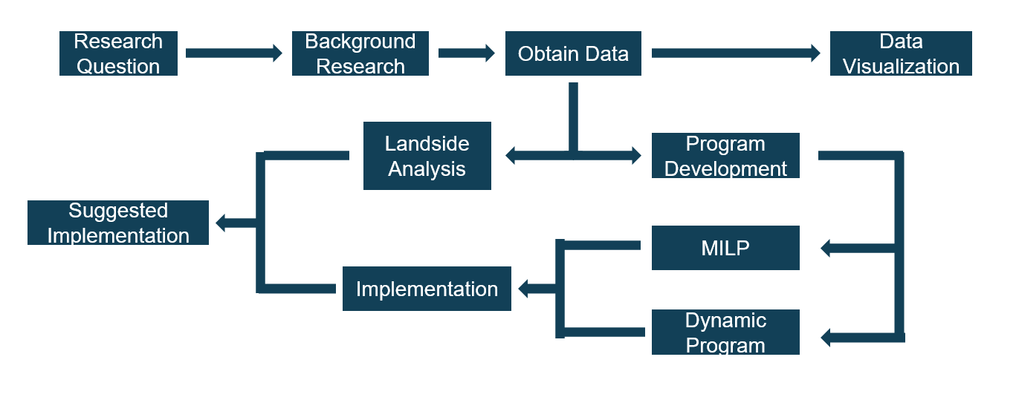

Figure a: Flow Chart of the research method used

The information from the ASPM database was used in a few ways when researching a more optimized flight distribution in the LA basin. To begin, the data is passed through a MATLAB script to clean it up and convert all necessary data to numbers. Taxi delays are then plotted for major airlines to give the user a visualization of the data. Using this information, windows of time are chosen to better optimize. Air delay times are then pulled from the dataset within the determined window of time and fed into the optimization program. The results then drive the suggested redistribution of flights.

Of course this shuffling of flights greatly affects the passengers flying at the given time so a closer look was taken at the landside as well. Data from *Los Angeles International Airport 2015 Air Passenger Survey Results and Findings* provided fantastic information on travel origins or destinations for passengers traveling through LAX. Pairing this information with Google Maps API, landside travel patterns were analyzed to determine the ideal airport from which to travel for each zip code in LA County. This information was also considered in the final suggestions.

American Airlines has regular service to every airport in the region as seen in figure **X** below. The majority of their LA operations are based out of LAX which is their 8th largest hub in the United States. At LAX there are a large amount of delays for both arrivals and departures while at other airports taxi delays are only due to departures, implying the wait is caused by factors at the flights destination. 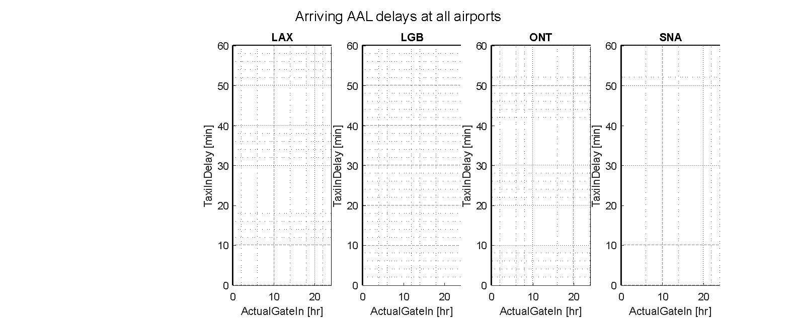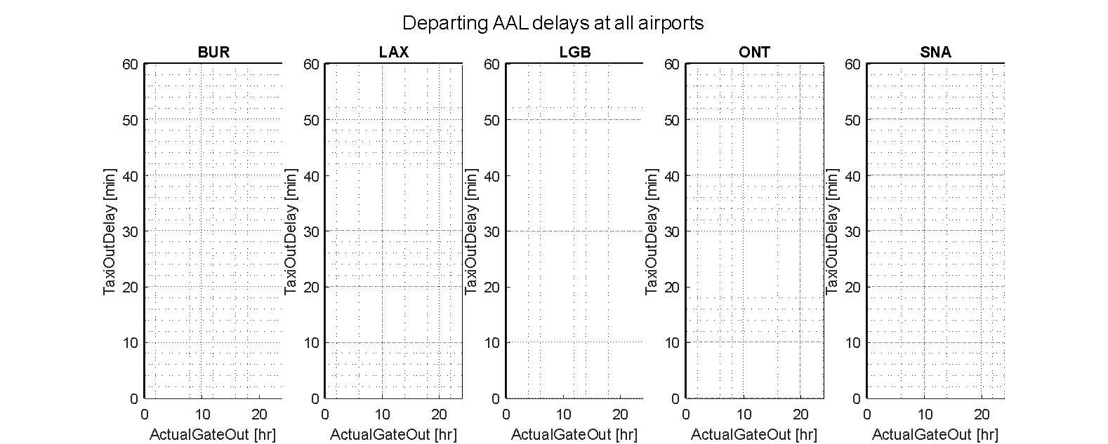

Beginning in 2016, Southwest Airlines serviced all five commercial airports in the LA basin. They serve mainly as a regional airline. While LAX is their eighth busiest airport, they experience relatively low taxi delays there along with the rest of the LA basin airports. Part of this could be due to their terminal one position at the end of the north runways. Overall, Southwest services the five LA airports in a consistent manner with regard to delays.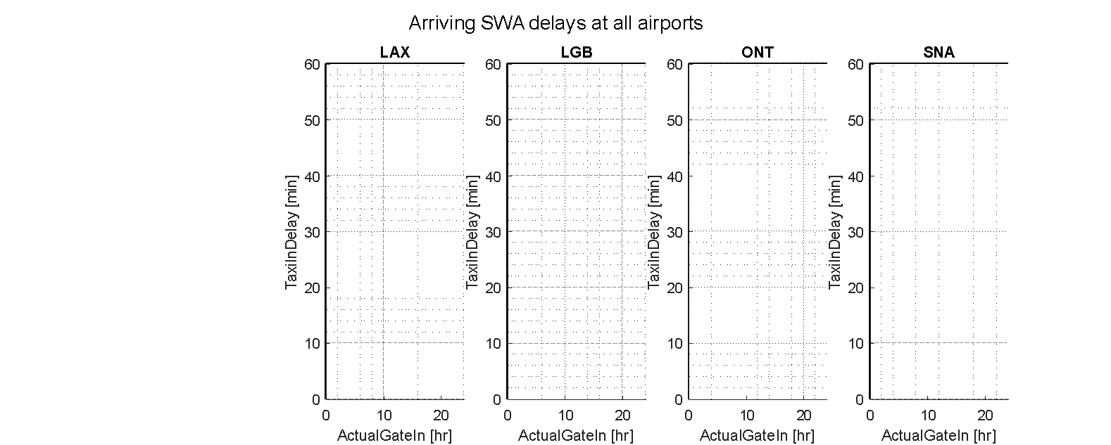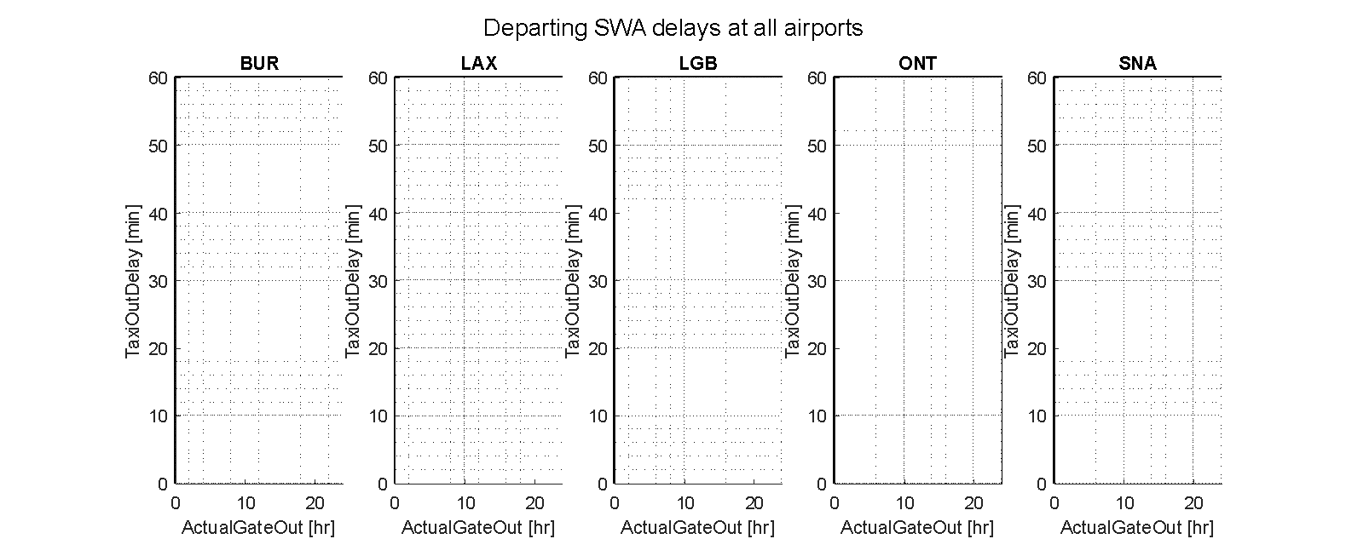

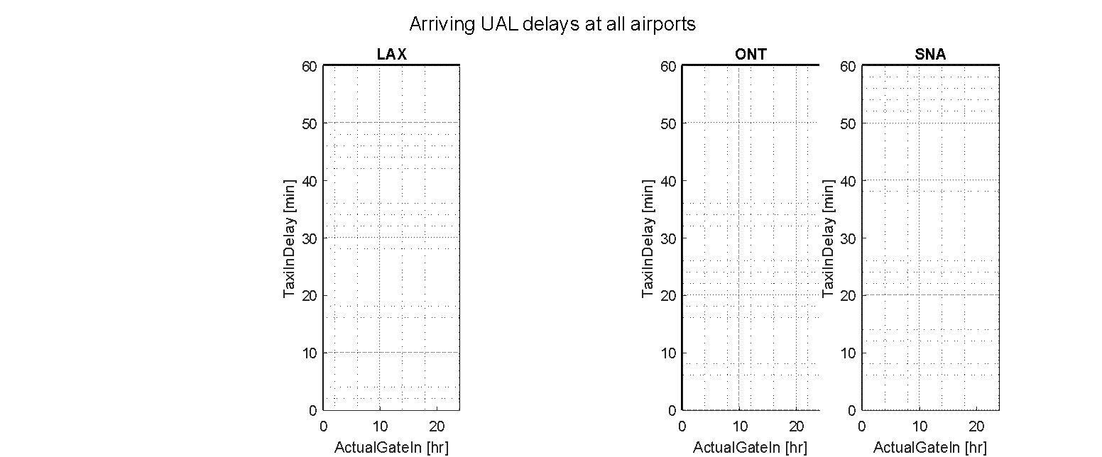United Airlines also operates heavily out of LAX in the LA basin with LAX being its seventh largest hub in the United States. The airline also serves BUR, ONT, and SNA but with less frequency than American Airlines. United falls victim to high delays in taxi time at LAX. While this may be the case, using LAX as a hub benefits United because of the international marked that is served by LAX.

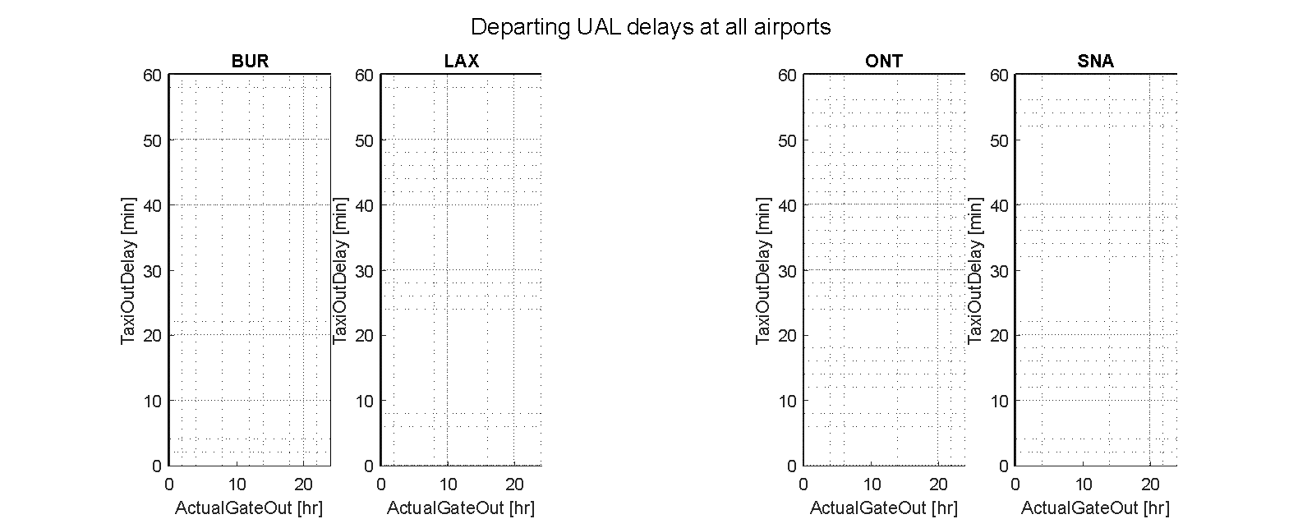

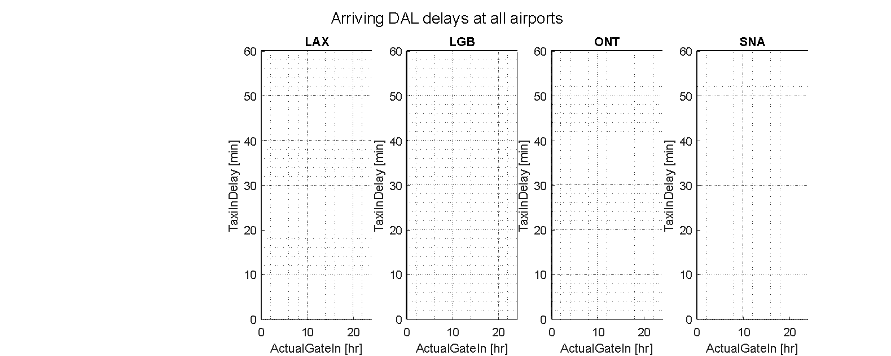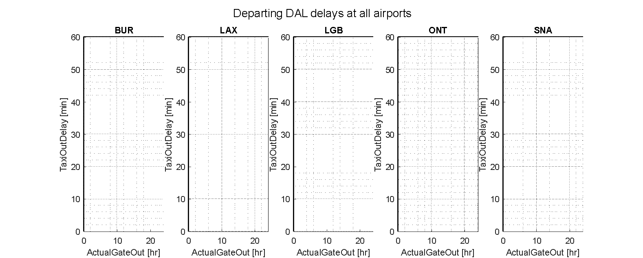Delta Airlines, similar to United and American, uses LAX heavily in the LA basin despite it not being one of their hub airports. The airline used Sea-Tac as its main Asian gateway. While their performance in delays at BUR, LGB, ONT, and SNA is trivial, Delta is also marred by taxi delays when operating out of LAX. This could be due to the placement of the American, Delta, and United terminals all next to each other at LAX.

Jet Blue is the sixth largest airline in the United States behind the previous four airlines and Air Canada. Currently they only operate at BUR, LAX, and LGB within the LA basin. Their delay trend is similar to Southwest’s delay trend at similar airports which suggests that possibly expanding their LA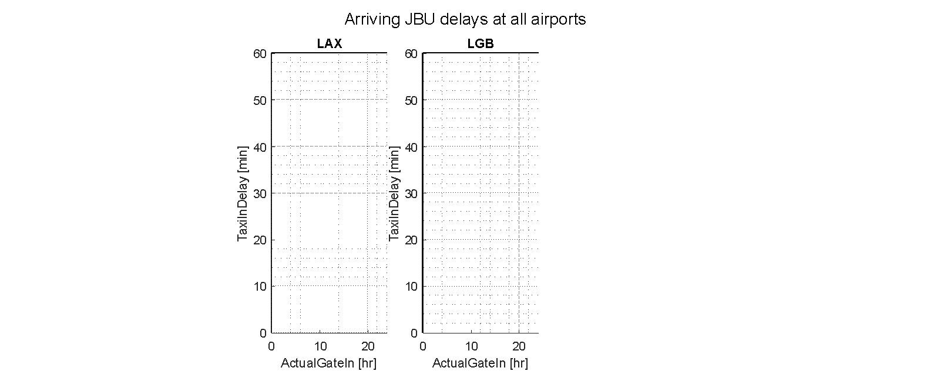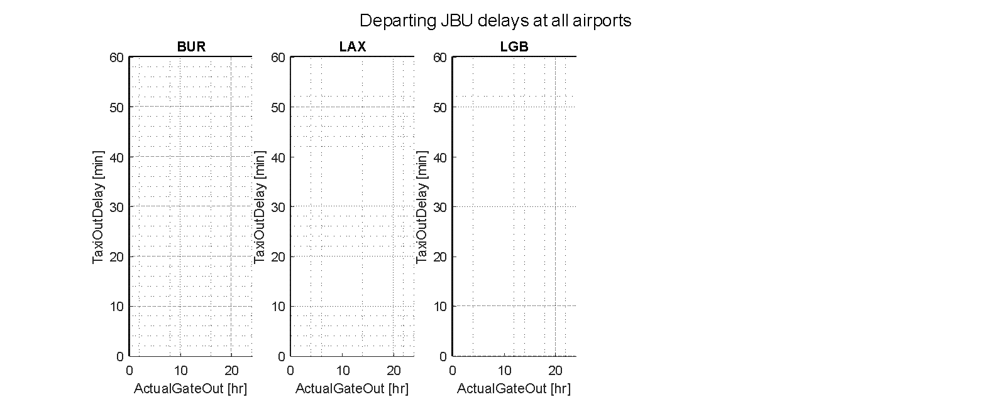 basin operations to other regional airports would not have an effect on their taxi delay times .